Retail Sales Dashboard Project

## Project Title:

# Retail Sales Dashboard using Power BI

## Submitted by :

Swathi Lanke

## Project Objective

The primary objective of this project is to build an interactive dashboard in Power BI that helps a retail business analyze its sales performance, customer behavior, and product performance across different regions and time periods. This dashboard assists in tracking key metrics and making strategic business decisions.

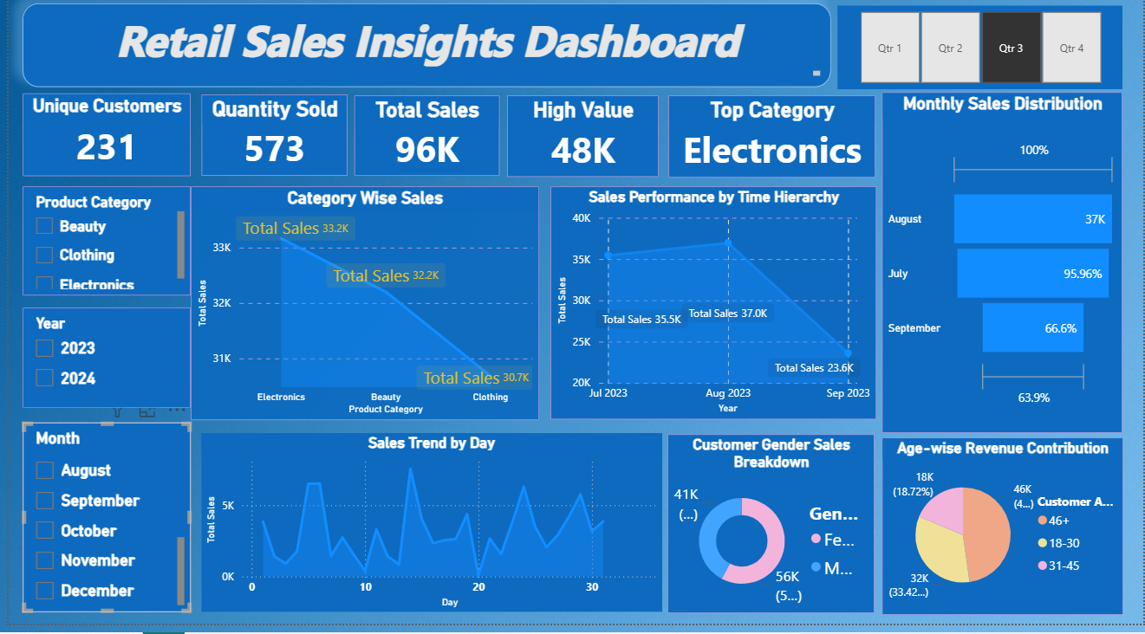

## Data Collection

The dataset was collected from a retail business and imported using Excel. The raw dataset included the following columns:

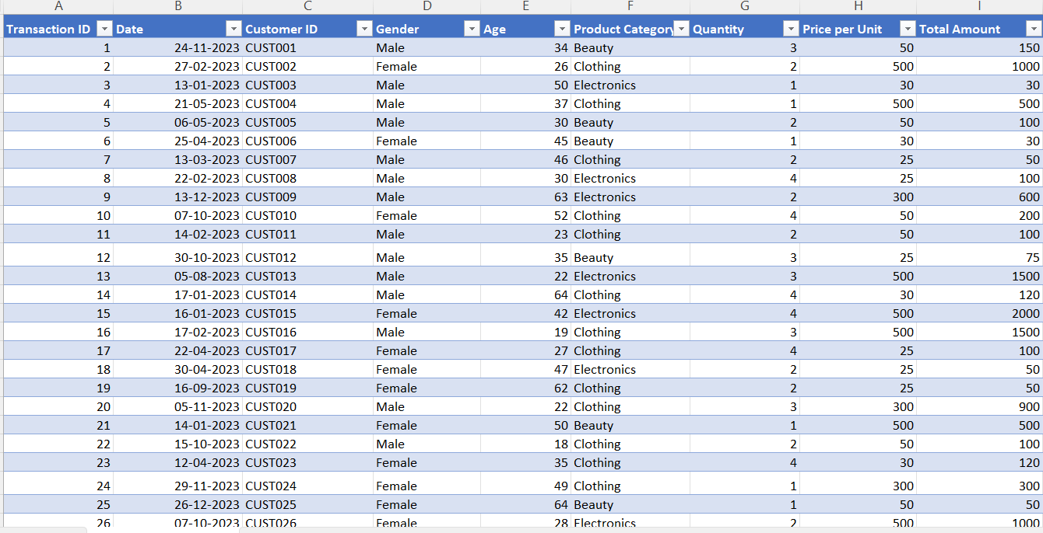

Column Name Description

-------------------- -----------------------------------

Transaction ID Unique identifier for each order

Order Date Date when the order was placed

Product Category Category of the product sold

Customer ID Unique identifier of the customer

Gender Gender of the customer

Quantity Number of items sold

Unit Price Price per unit

Total Amount Calculated as Quantity × Unit Price

Age Calculated the customer age

## Cleaned and Enriched Dataset Columns

After data cleaning and transformation in Excel and Power BI, the following additional columns were created:

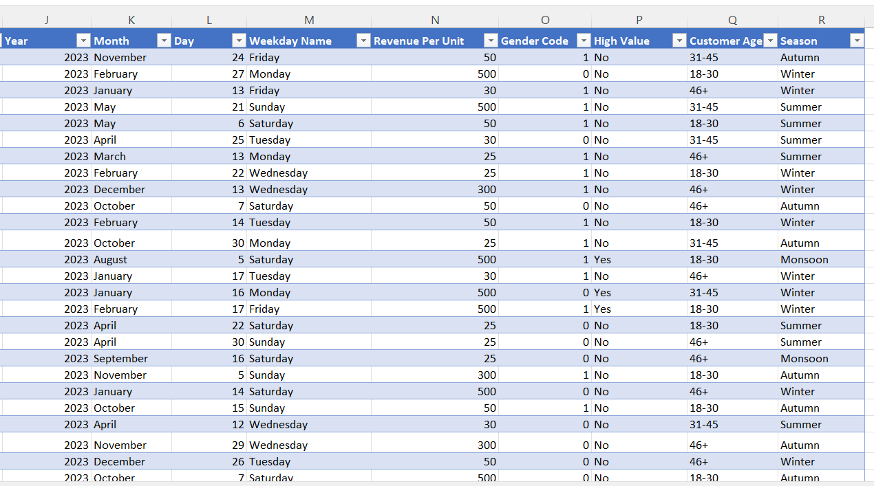

Column Name Description

--------------------- ------------- ------------------------------------

Weekday Name Day of the week from order date

Season Derived from month of order date

Customer Age Age calculated from DOB

Year-Month For time trend analysis

Quarter Quarter extracted from order date

Year Year from order date

## Excel Formulas Used To Created The Additional Columns

Month TEXT(B2, "mmmm")

Day DAY([@Date])

Weekday Name TEXT([@Date], "dddd")

Revenue per unit ([@[Total Amount]] / [@Quantity])

Gender Code IF([@Gender]="Male", 1, 0)

High Value IF([@[Total Amount]] > 1000, "Yes", "No")

Customer Age IF(E2<=30, "18-30", IF(E2<=45, "31-45", "46+")

Season IF(OR(MONTH(B2)=3,MONTH(B2)=4,MONTH(B2)=5), "Summer",

IF(AND(MONTH(B2)>=6,MONTH(B2)<=9), "Monsoon",

IF(AND(MONTH(B2)>=10,MONTH(B2)<=11), "Autumn", "Winter")))

Quarter ROUNDUP(MONTH(B2)/3, 0)

Year-Month TEXT(B2, "yyyy-mm")

## Analysis Questions

1. What is the total sales revenue?

2. Which product category generated the highest sales?

3. What is the average order value?

4. Which day ,month, quarter had the highest sales?

5. What is the trend of total sales over time(daily , monthly) ?

## Customer Analysis Questions

6.How many unique customers made purchase?

7.Who are the top 10 customers by total spend?

8.What is the gender wise distribution of customers?

9.Is there a pattern in purchasing behavior by age group?

10.Do male or females spend more on average?

## Product Level Insights Questions

11.which product category sells the most units?

12.which product category is the most profitable?

13.What is the average price per unit per category?

14.Which product category is popular among different age groups?

## Time Based Patterns Questions

15.Which days of the week see the highest sales?

16.What is the seasonal trend in sales (Q1,Q2,Q3,Q4)?

17.Are sales increasing or decreasing over time

## Pivot Table Analysis (Excel)

### Step 1: Create Pivot Table

* Make sure your table has **headers** (e.g., Date, Product Category, Total Amount, etc.)
* Select your entire data table.
* Press **Ctrl + T** to convert it into a **structured Excel Table** (if not already).

### Step 2: Insert the First Pivot Table

1. Click anywhere in your table.
2. Go to **Insert > PivotTable**.
3. In the dialog box:
   * Choose **"Existing Worksheet"**
   * Click in **Location box**, and click on the sheet (e.g., Pivot Analysis) and choose cell A1.
4. Click **OK**.

### Build the First Pivot Table

**Pivot 1: Sales by Product Category & Month**

**Rows**: Product Category

**Columns**: Month

**Values**: Sum of Total Amount

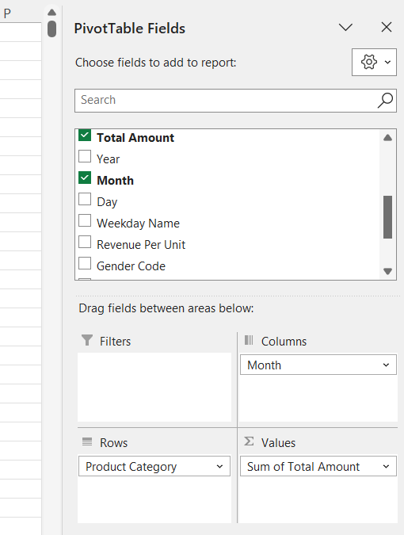

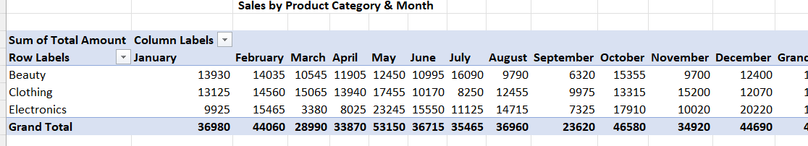

**Pivot 2: Quantity & Revenue By Product Category**

**Rows**: Product Category

**Values**: Sum of Total Amount ,Total Quantity

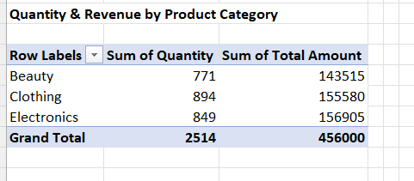

### ****Pivot Tables Created:****

| **No.** | **Pivot Title** | **Insights Focus** |
| --- | --- | --- |
| 1 | Sales by Product Category & Month | Which categories perform best in which months |
| 2 | Quantity & Revenue by Product Category | Product-wise performance by units and revenue |
| 3 | Sales by Gender | Sales and quantity split by male/female customers |
| 4 | Revenue by Age Group | Which age group contributes most to total revenue |
| 5 | Sales by Weekday | Identifying best-performing days |
| 6 | Monthly Sales Trend | Understanding seasonality or monthly spikes |

Repeat for the Other 5 Tables

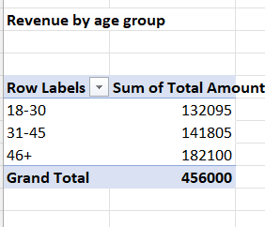

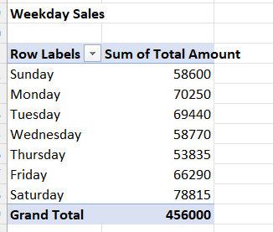

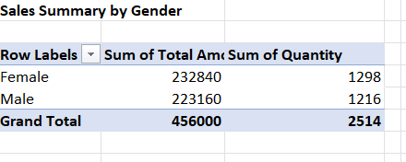

### Pivot Table Analysis (Excel)

Before building the Power BI dashboard, Excel Pivot Tables were used for preliminary data analysis. These helped identify high-performing categories, customer segments, and time-based patterns.

| **No.** | **Pivot Table** | **Insights Gained** |
| --- | --- | --- |
| 1 | Sales by Product Category & Month | Identify seasonal category performance |
| 2 | Quantity & Revenue by Product Category | Compare product performance by units and revenue |
| 3 | Sales by Gender | Analyze sales split between male and female |
| 4 | Revenue by Age Group | See which age group spends the most |
| 5 | Sales by Weekday | Understand which days generate more sales |
| 6 | Monthly Sales Trend | Spot overall growth or decline month-to-month |

These pivot tables were created on a single worksheet in Excel and formatted for clarity and comparison.

## Power BI Implementation

Load the data into **Power BI**, built a **data model** , and added a **date table** for time- based analysis.:

- Open Power BI Desktop

- Click Home > Get Data > Excel

## Creating a Date Table

-A **Date Table** is **not a measure**.

-It is a **separate table** in our data model, not just a column.

-Create it using a **DAX formula** to generate all dates between a start and end date.

Create Date Table using DAX

DateTable = ADDCOLUMNS ( CALENDAR ( MIN(Sales[Order Date]), MAX(Sales[Order Date]) ),

"Year", YEAR([Date]), "Month Number", MONTH([Date]), "Month", FORMAT([Date], "MMMM"),

"Quarter", "Q" & FORMAT([Date], "Q"),"Year-Month", FORMAT([Date], "YYYY-MMM"),

"Weekday", FORMAT([Date], "dddd")

### Next Step: Mark as Date Table

After creating it, **mark it as a date table**:

Go to **Table Tools > Mark as Date Table**

Select the Date column (auto-created by CALENDAR)

Click OK

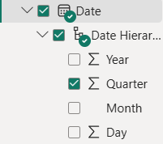

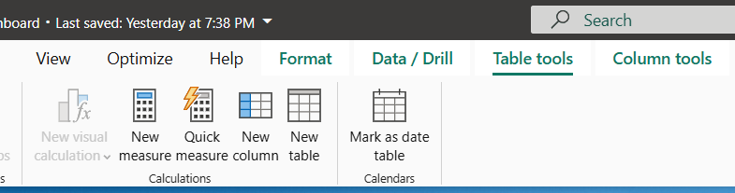

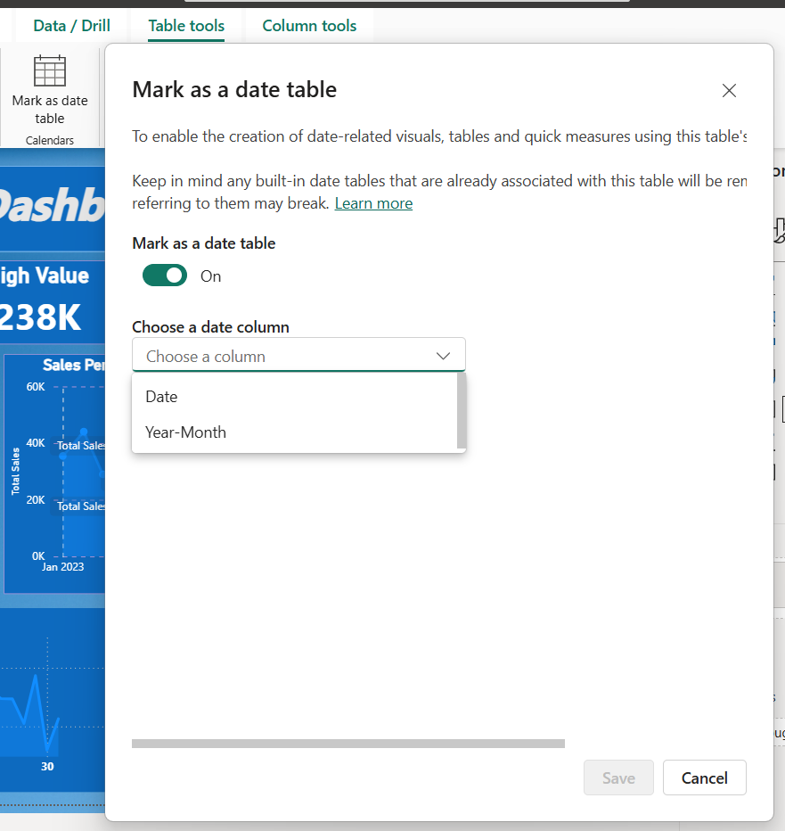

## DAX Measures : Calculated Columns

In a table view a created calculated columns DAX formulas:

Click **Modeling > New Column**.

Enter this formula:

In a table view a created calculated columns DAX formulas:

Month Number MONTH('Retail sales Dataset'[Date])

Year Month FORMAT('Retail sales Dataset'[Date], "YYYY-MM")

Year Month Number YEAR('Retail sales Dataset'[Date]) * 100 + MONTH('Retail sales

Dataset'[Date])

Season SWITCH(TRUE(),MONTH(Sales[Order Date]) IN {12,1,2}, "Winter", MONTH(Sales[Order Date])

]) IN {12,1,2}, "Winter", MONTH(Sales[Order Date]) IN {3,4,5}, "Spring", MONTH(Sales[Order

Date]) IN {6,7,8}, "Summer", MONTH(Sales[Order Date]) IN {9,10,11}, "Fall", "Unknown")

Revenue 'Retail Sales Dataset'[Quantity] * 'Retail Sales Dataset'[Price per Unit]

### What is a Measure?

A **measure** is a DAX formula used to **calculate values on the fly** based on your data.

It is not stored row-by-row like a calculated column.

It’s used in visuals like cards, charts, tables, etc.

Open your Power BI project.

Click on the table where you want the measure.

In DATA PANE

Go to **Modeling > Right click > New Measure** > Click new measure

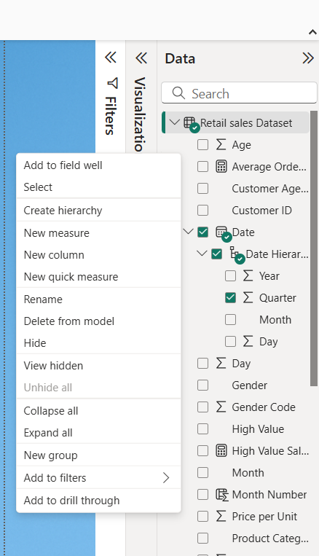

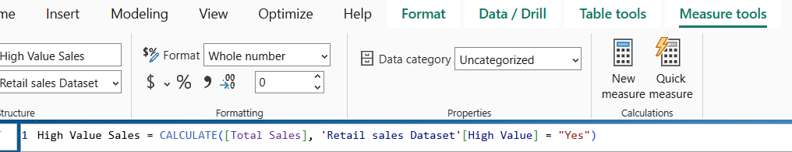

Write our DAX formula in it

### DAX formulas for Measures:

Average Order Value = DIVIDE([Total Sales], DISTINCTCOUNT('Retail sales Dataset'[Transaction ID]))

High Value Sales = CALCULATE([Total Sales], 'Retail sales Dataset'[High Value] = "Yes")

Quantity Sold = SUM('Retail sales Dataset'[Quantity])

Top Category = CALCULATE(MAX('Retail sales Dataset'[Product Category]),

TOPN(1, SUMMARIZE('Retail sales Dataset', 'Retail sales Dataset’

[Product Category], "Total", SUM('Retail sales Dataset'[Total Amount]

)), [Total], DESC))

Total Sales = SUM('Retail sales Dataset'[Total Amount])

Total Units Sold = SUM('Retail sales Dataset'[Quantity])

Unique Customers = DISTINCTCOUNT('Retail sales Dataset'[Customer ID])

Total Revenue = SUM('Retail sales Dataset'[Revenue])

Average Transaction Value = AVERAGE('Retail sales Dataset'[Total Amount]

Total Transactions = COUNTROWS('Retail sales Dataset')

High-Value Transactions = CALCULATE(COUNTROWS('Retail sales Dataset'),

'Retail sales Dataset'[High Value] = "Yes")

## ****Dashboard Visual – Layout Overview****

### ****KPI Summary (Top Row)****

**Visual Type**: Card Visuals

**Metrics Displayed**:

* + **Unique Customers**
  + **Quantity Sold**
  + **Total Sales**
  + **High Value** (Max Order Value)
  + **Top Category** (Best Performing Product Category)

### ****Filters Panel (Left Sidebar)****

**Visual Type**: Slicers

**Fields Used**:

* + **Product Category**
  + **Year** (2023, 2024)
  + **Month & Date**

### ****Category Analysis****

**Visual Type**: Line Chart

**Title**: Category Wise Sales

**Fields Used**:

* + X-axis: Product Category
  + Y-axis: Total Sales

### ****Sales Trend (Monthly)****

**Visual Type**: Line Chart

**Title**: Sales Performance by Time Hierarchy

**Fields Used**:

* + X-axis: Year/Month
  + Y-axis: Total Sales

### ****Sales Trend (Daily)****

**Visual Type**: Line Chart

**Title**: Sales Trend by Day

**Fields Used**:

* + X-axis: Day
  + Y-axis: Total Sale

### ****Customer Segments****

**A. Gender Breakdown**

* + **Visual Type**: Donut Chart
  + **Title**: Customer Gender Sales Breakdown
  + **Fields**: Gender vs Sales

**B. Age-wise Revenue**

* + **Visual Type**: Pie Chart
  + **Title**: Age-wise Revenue Contribution
  + **Fields**: Age Groups (18–30, 31–45, 46+) vs Sales

### ****Sales Distribution****

**Visual Type**: Funnel Chart

**Title**: Monthly Sales Distribution

**Fields Used**:

* + Y-axis: Month
  + X-axis: Total Sales (%)

### ****Quarter Filter (Top Right)****

**Visual Type**: Slicer (Button Style)

**Values**: Qtr 1, Qtr 2, Qtr 3, Qtr 4

### ****Key Insights from this dashboard****

**Key Insights:**

* **Electronics** is the top-performing category in terms of sales.
* Highest sales occurred in **May** and **December**, as shown in the funnel.
* **High-value customers** significantly contribute to revenue.
* Majority of revenue comes from the **31–45** age group.
* **Sales spikes** are visible on certain days, suggesting promotional effectiveness or seasonal demand.
* **Female customers** slightly outnumber male customers in total sales volume.

This dashboard supports actionable insights for retail decision-makers, helping optimize marketing, inventory, and customer engagement strategies.